**READING SECTION**

**TEXT I. Read the following text and answer the questions**.

**JOHN HARRISON**

John Harrison has a wonderful job. He is an ice-cream “taster.” He tastes (tries) different kinds of ice cream for a company. Then, he says he likes **it** or doesn’t like it. All members of his family worked in the ice-cream business. His grandfather, his father, and his uncle owned small ice-cream factories, and he grew up in this industry. After finishing school, he wanted to be a lawyer, but Dreyer’s, a famous American ice-cream company, called him and asked him to be their taster. Harrison joined the company in 1980, and he is still working **there**. He created more than 100 new kinds of ice cream. One popular example is an Oreo and ice cream mixture.

Every day, he works for four-five hours and tries 60 new kinds of ice-cream. “I taste it with my eyes first. When the ice-cream doesn’t look good, forget it. I don’t eat it.” He puts a thermometer into the ice-cream. He uses **it** to check the temperature. He tastes it at -12˚C. When it’s too cold, his taste buds can’t work well. He puts the ice-cream in his mouth, waits for a while, and takes it out. Harrison doesn’t eat it. “Taking the ice-cream out of my mouth is not easy of course, but if I eat it, I would be too full, and I couldn’t continue.”

A company insured Harrison’s tongue for a million dollars. His taste buds are so good that he can taste the difference between 12% and 11% butter in the ice-cream. “I have the same tongue with everyone else, but my taste buds are educated. I learned about creams and sugars at a very early age,” he says. Harrison takes good care of his tongue. He drinks a special tea to clean his tongue every day. He doesn’t eat too much garlic or onion. He doesn’t smoke and stays away from alcohol. “It’s an important job. Companies close down because of flavor mistakes,” he says.

He suggests fresh tastes for summer like strawberry and mango, and strong aromas like bitter chocolate or mint, after a heavy and spicy meal. What do you think Harrison’s favorite ice-cream is after all these years? It is vanilla, the best-selling and most popular kind of ice-cream everywhere.

**A. What do following words refer to?**

1. it (para. 1) : _______________________________

2. there (para. 1) : _______________________________

3. it (para. 2) : _______________________________

**B. Read the text, and mark the statements true (T) or false (F).**

T F 1. Only John Harrison worked in ice-cream business in his family.

T F 2. Harrison wanted to study law after school.

T F 3. Harrison thinks that the look of the ice-cream is not important.

**C. Answer the following questions**.

1. When did Harrison start working at Dreyer’s? ________________________________________________________________________.

2. Why does Harrison taste the ice-cream at -12˚C degrees? ________________________________________________________________________.

3. What is different about Harrison’s tongue? _________________________________________________________________________.

4. What does Harrison do to take care of his tongue? Write two things.

a) ______________________________________________________________________.

b) ______________________________________________________________________.

***KEY***

***PART A.***

***1. (the) ice cream***

***2. at / in (the) company / Dreyer’s***

***3. (the) thermometer***

***PART B. 1. F 2. T 3. F***

***PART C.***

***1.(He started working at Dreyer’s / there) in 1980.***

***2. When the ice cream / it is too cold, his taste buds can’t work well.***

***3.His taste buds are educated.***

***4.He drinks a special tea (to clean his tongue) (everyday).***

***He doesn’t eat too much garlic / onion.***

***He doesn’t smoke.***

***He stays away from alcohol.***

**TEXT II**

1. **Read the following text, and answer the questions**.

Loic, an archeologist from France, and Türkan, an English teacher from Turkey, are an unusual couple. What makes them different is that they moved from the city to a village a year ago. They thought life in the city was too tiring and stressful, so they decided to move to the countryside.

Another interesting thing about this couple is that they built their own house with their hands. They worked really hard all summer to finish it before the cold days came. They finished it at the end of August. They used natural materials like wood and hay. Türkan has a blog, and she wrote the story of how they built their cottage step by step there. She also shared the pictures of their work with her followers. **They** saw the pictures and went there to help the couple. They didn’t want money for their work. Everyone enjoyed working together to build the cottage. At the end, Türkan and Loic had a beautiful **one**.

Loic and Türkan also have a beautiful garden, and they like working in it. They have tomatoes, garlic, carrots, and many other vegetables and fruit in the garden, so they don’t need to pay for food. They have a cute little cat. He is called Chip. Loic made a cat house from empty beer bottles in the garden. Chip loves the cat house. Many small animals, like small mice and snakes, share **his** house with him.

Loic and Türkan think they made a very good decision in moving to the village because they say it’s important to enjoy the small things in nature. They like watching the beautiful mountain scenery and the sunsets, having long walks in the forest, and eating fresh and free food from their garden, instead of living with all the stresses of a busy city.

The relaxing life in the village has many advantages. They do sports in the nature, they live without money, and they have a balanced diet with all the healthy food there. The only downside is that they miss their friends and families. The only way to talk to them is writing e-mails at the Internet café in the nearby town because they don’t have telephones. If you want to read their story, you can follow them on yesilatlas.net.

**A. What do the following words refer to?**

1. They (para. 2) : ______________________________

2. one (para. 2) : ______________________________

3. his (para. 3) : _____________________________

**B. Read the text, and mark the statements true (T) or false (F).**

T F 1. Loic and Türkan worked in winter to build their house.

T F 2. Loic and Türkan got no help when they made their house.

T F 3. Loic and Türkan don’t buy vegetables at the supermarket.

**C. Answer the following questions.**

1. Why did Türkan and Loic move to the countryside? ________________________________________________________________________

2. What did Loic use to make a cat house? ________________________________________________________________________

3. What are the examples of small things they enjoy in nature? Write two.

a) ______________________________________________________________________

b) ______________________________________________________________________

4. Why do they have a balanced diet? ________________________________________________________________________

5. How do they talk to their families? ________________________________________________________________________

***KEY***

***PART A.***

***1. (her / Türkan’s / the) followers***

***2. (the / a) cottage***

***3. Chip’s / (the) cat’s***

***PART B.***

***1. F 2. F 3. T***

***PART C.***

***1. (Because) (they thought) the life in city was too tiring / stressful.***

***2. (He / Loic used) (empty) (beer) bottles.***

***3. (They like) (watching) the beautiful mountain scenery / the sunsets***

***(They like) (having) (long) walks in the forest***

***(They like) (eating) fresh / free food from their garden***

***4. (Because) they eat healthy food.***

***(Because) they have healthy food in their garden.***

***(Because) they have a balanced diet with all the healthy food there.***

***(Because) there is healthy food there.***

***5. They write e-mails to them.***

***The only way to talk to them is writing e-mails (at the Internet café).***

**TEXT III**

**Read the texts, and answer the questions that follow**.

**Great Places to See**

Lisbon, Portugal is a great place for a weekend because there is a lot to see and do. There are flights from European cities every day. There’s a bus from the airport to the city. There are also taxis, and they aren’t expensive. After you arrive, travel around Lisbon by tram – they’re great!

There are great cafés and restaurants on every street in Lisbon. Try the delicious Portuguese cakes.

There are some beautiful buildings in Lisbon, and very good museums, too. Also, go see a Fado show because this Portuguese music is very beautiful.

Shopping in Cairo, Egypt, was great. There were many places to go shopping there. My favorite place was Khan al-Khalili market. It was fantastic! I was there in the afternoon, and there were a lot of people there. There were many things to buy and they weren’t very expensive. There were a lot of coffee shops in the market, but they weren’t very big. They were usually small and friendly. The coffee was delicious. There was only one problem – I hurt my ankle. Luckily, some nice people called a taxi for me.

The old town of Hanoi in Vietnam is very interesting. Go shopping in the historic streets, have a cup of coffee in a café and eat the local street food – it’s amazing! The town is small, so walk or rent a bike. Later, you can relax under the trees near Hoàn Kiếm Lake. Go to Hanoi in the spring or autumn. It’s very hot in the summer.

Vancouver, Canada is a great place to see. Take the bus to the Museum of Anthropology near the University. The museum has 13,000 examples of art from many countries.

Stanley Park is near the city center. It’s a great place for families: there’s Vancouver Aquarium and a small train for children, a forest with a lot of animals and birds, and sports like golf and tennis. Rent a bike – it’s a good way to see the park.

Don’t forget to see Vancouver’s Chinatown. It’s a fascinating place to visit. Go shopping in the markets and eat in one of the delicious restaurants. When you’re tired, relax in the beautiful Sun Yat Sen Garden.

**A. Fill the gaps with ONE WORD from the text**.

* You can get to Lisbon from the airport by (1) ___________________ or (2) ___________________.
* The coffee shops in Khan al-Khalili market were (3) __________________ and (4) _________________.
* Rent a bike in these cities: (5) ___________________ and (6) ___________________.
* You can find good museums in these cities: (7) ___________________ and (8) ___________________.

**B. Answer the following questions according to the text.**

1. Why is it easy to get to Lisbon from other places in Europe? _________________________________________________________________________________.

2. What is Fado? _________________________________________________________________________________.

3. What did the writer like about Cairo? Write one thing. _________________________________________________________________________________.

4. What problem did the writer have in Khan al-Khalili market? _________________________________________________________________________________.

5. When should you go to Hanoi? _________________________________________________________________________________.

6. Why is Stanley Park a good place for families? Write two reasons.

a) _______________________________________________________________________________.

b) _______________________________________________________________________________.

7. Where can you have a rest in Chinatown? _________________________________________________________________________________.

***KEY:***

***PART A:***

***1. & 2. bus / taxi 3. & 4. small / friendly***

***5. & 6. Hanoi / Vancouver 7. & 8. Lisbon / Vancouver***

***PART B:***

***1. (Because) there are flights (from European cities) every day***

***2. (Fado is / It’s a type of) Portuguese music***

***3. (S/He liked)(the) shopping / Khan al-Khalil market / (the) coffee (shops) / (the)(nice) people***

***4. S/He hurt her / his ankle S/He got hurt / an injury***

***5. (In the) spring or autumn***

***6. It has (got) an aquarium / (the) Vancouver Aquarium***

***It has (got) / There is a small train for children (there)***

***7. (You can have a rest/You can relax) in the (beautiful) Sun Yat Sen Garden.***

**TEXT IV**

**Read the text, and answer the questions that follow.**

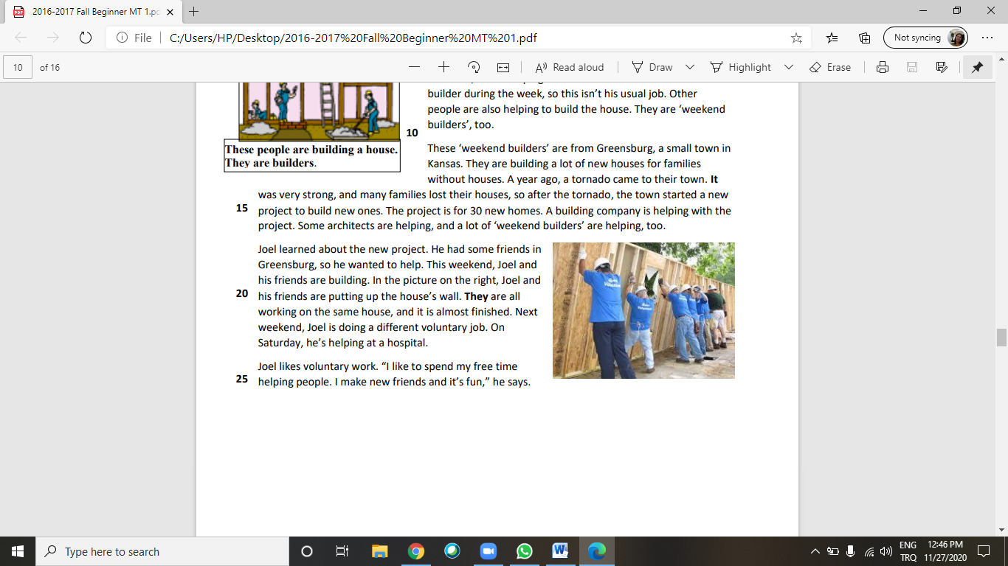**A Different Kind of Weekend**

Joel Connor is a banker. He works in a bank in Wichita, Kansas. His job is a typical nine-to-five, Monday-to-Friday **one**, so at the weekend, he does something different. He does voluntary work. Voluntary work is work without getting any money. Joel helps different organizations and people for free at the weekend. Every weekend, there’s a different job to do. This weekend, Joel is helping to build a new house. He isn’t a builder during the week, so this isn’t **his** usual job. Other people are also helping to build the house. They are ‘weekend builders’, too. These ‘weekend builders’ are from Greensburg, a small town in Kansas. They are building a lot of new houses for families without houses. A year ago, a tornado came to their town. **It** was very strong, and many families lost their houses, so after the tornado, the town started a new project to build new ones. The project is for 30 new homes. A building company is helping with the project. Some architects are helping, and a lot of ‘weekend builders’ are helping, too. Joel learned about the new project. He had some friends in Greensburg, so he wanted to help. This weekend, Joel and his friends are building. In the picture on the right, Joel and his friends are putting up the house’s wall. **They** are all working on the same house, and it is almost finished. Next weekend, Joel is doing a different voluntary job. On Saturday, he’s helping at a hospital. Joel likes voluntary work. “I like to spend my free time helping people. I make new friends and it’s fun,” he says.

**A. What do the following words in the text refer to?**

1. ‘one’ refers to : _________________________________.

2. ‘his’ refers to: _________________________________.

3. ‘It’ refers to : _________________________________.

4. ‘They’ refers to : _________________________________.

**B. Circle T (true), F (false) or NI (no information).**

T F NI 1. Joel Connor likes his job as a banker.

T F NI 2. Joel doesn’t build houses every weekend.

T F NI 3. Joel also works as a builder during the week.

T F NI 4. There are 30 people helping with the project.

T F NI 5. The ‘weekend builders’ work alone on the project.

**C. Answer the following questions according to the text**.

1. Who are the ‘weekend builders’ building houses for? _______________________________________________________________________________.

2. What is Joel doing this weekend? _______________________________________________________________________________.

3. What is Joel’s voluntary project next weekend? _______________________________________________________________________________.

4. Why does Joel like voluntary work? Write two reasons.

a) ____________________________________________________________________________.

b) ____________________________________________________________________________.

***KEY:***

***PART A:***

***1. job 2. Joel Connor’s /Joel’s 2. (the) tornado 3. Joel (Connor) and his friends***

***PART B.***

***1. NI 2. T 3. F 4. NI 5. F***

***PART C.***

***1. (For) families / people without houses***

***2. (He’s) helping to build a new house***

***3. (He’s) helping at a hospital***

***4. He likes to spend (his free) time helping people / He likes helping people***